**12A – Reflection & Transmission**

**(Normal Incidence)**

**Topics:** Reflection and transmission, boundary conditions, complex exponentials.

**Summary:** Students begin by expressing in exponential notation the boundary condition on the parallel components of an EM plane wave for normal incidence at the interface between two media. They can then find the phase shift and amplitude for the reflected wave by considering representations of the electric field in the complex plane, first for when the amplitude of the transmitted wave is smaller than for the incident, and then when the opposite is true. Students should conclude that the frequencies of all three equations must match for the boundary condition to hold at all times. A second boundary equation is found by considering the electric and magnetic fields of the reflected wave. The remaining tasks connect the amplitude and phase shift of the reflected wave with the refractive indices of the two materials.

**Written by:** Charles Baily, Steven Pollock and Michael Dubson.

**Contact:** Steven.Pollock@Colorado.EDU

**Comments:** Warning (!): Portions of this tutorial have not been validated or field-tested, but we expect students to be able to finish the tasks in less than 50 minutes. A somewhat different version was used in our class, and the tasks related to representations in the complex plane are new. We anticipate that this way of representing the electric field will be more intuitive for seeing how the electric fields must match up in order for the boundary condition to be satisfied at all times. It’s important that students find the correct final equation on pg. 1, since it will be used in subsequent tasks. The initial expressions assume without comment that there can only be a phase shift in the reflected wave; more general expressions would likely tempt students to spend too much time considering the myriad ways the arrows in the complex plane could combine to give an answer that works just at *t* =0. A number of students will have issues with the algebra when solving two equations for two unknowns on the final page. Checking their answers for the case when the refractive indices are equal may help them to see whether they have it right. There may be some confusion on the final page about the amplitude for the reflected wave being a positive or negative quantity; all of the amplitudes are assumed to be positive in the preceding pages, but in this final task we’re expecting students will have seen enough times the connection between minus signs and phase shifts. No explicit phase shift (or +/– signs) makes the expressions as simple as possible for the algebraic tasks.

**A.** An electromagnetic plane wave is traveling through region **1** (a material with index of refraction ), and encounters a material in region **2** (index of refraction ), with the boundary located at . The incident wave () gives rise to a reflected wave () and a transmitted wave ().

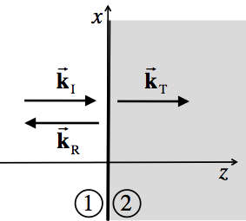

With the incident wave linearly polarized in the *x*-direction, the electric fields of the incident, reflected and transmitted waves can each be represented by the following complex exponentials:







According to Faraday’s Law, the parallel component of the total electric field on either side of the boundary must be the same at all times:



Use the information given to re-write this boundary condition using the complex exponential notation from above.

Now, write out this boundary condition at .

You may continue, but be sure to check your answers with an instructor.

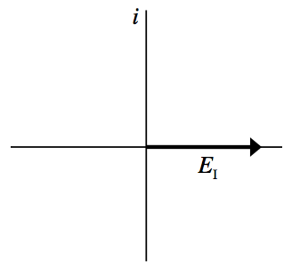

**B.** The arrows in the two diagrams at right represent the electric fields of the incident and transmitted waves in the complex plane at . Notice that in this case 

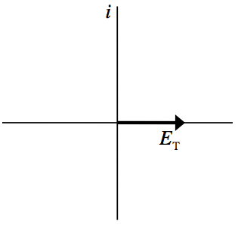

In order for the following boundary condition to be satisfied



what is the phase shift  for the *reflected* wave? [Hint: ]

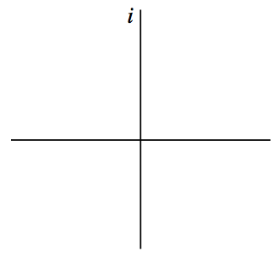

Use the axes at right to draw an arrow representing the magnitude and direction of the electric field for the *reflected* wave at .

**C.** With the *incident* E-field at  shown below at left, use the remaining axes to draw arrows representing the E-fields of the *reflected* and *transmitted* waves for the case . Be sure to label your arrows.

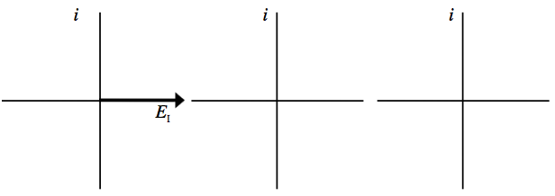

What is the phase shift  of the *reflected* wave in this case?

Use the diagram above to draw the *incident* E-field at a later time . Be sure to think carefully about which direction  rotates in the complex plane.

Boundary conditions must be satisfied at all times (not just at ). If we solve for  in the time-dependent equation from the first page:



Notice that the quantity on the *left side* of the equation is an entirely real constant. For this equality to hold at all times, what must be true about the quantities  and ? Briefly explain your reasoning.

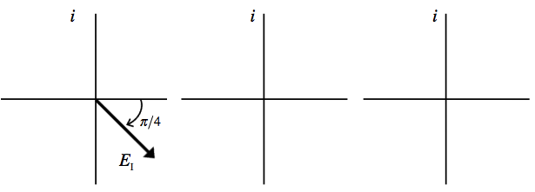**D.** With the *incident* E-field at  shown below at left, use the remaining axes to draw arrows representing the E-fields of the *reflected* and *transmitted* waves for the case . Be sure to label your arrows.

**E.** Assume that both materials have a negligible magnetic permeability (). The following four boundary conditions for the electric and magnetic fields must be true at the interface of materials  & :



Which of these four boundary conditions (i-iv) could be used to get the following equation? [ &  are the wave speeds in regions 1 & 2]



[Hint: Recall that for EM plane waves .]

Show how you can arrive at this boundary equation by taking the direction of propagation for the reflected wave into consideration.

**F.** For simplicity, let  in these two boundary equations, where  could be positive or negative, depending on the phase shift:

**(Eq. I)**  **(Eq. II)** 

Use equations **I** & **II** to solve for  in terms of . Explain in words whether your answer makes sense in the limit .

Use this result to solve for  in terms of . Explain in words whether your answer makes sense in the limit .

For what values of  will the *reflected* wave be  out of phase with the incident wave?

If the *reflected* wave is  out of phase with the incident wave, does this mean that light in medium 2 travels *faster* or *slower* than light in medium 1?